Week 7

To configure an AWS Lambda function that is triggered by Amazon S3 events and updates Amazon DynamoDB, the following prerequisites must be completed:

First, create a bucket in **Amazon S3**. This bucket will store files and act as the event source. Whenever a file is uploaded or modified in the bucket, it will generate an event that can trigger a Lambda function.

Second, create a table in **Amazon DynamoDB** with the name **newtable**. The table should have a **partition key called "unique"** with the data type **String**. This table will be used to store the information about the files that are uploaded to the S3 bucket.

Third, create a function in **AWS Lambda** using the Python runtime. In this function, add the provided Python code. The code reads the event details generated by S3, such as the bucket name, object name, file size, event type, and event time.

Fourth, connect the S3 bucket to the Lambda function by adding an **S3 trigger**. Configure the trigger so that the Lambda function runs whenever an object is created or uploaded in the bucket.

Finally, test the system by uploading a file to the S3 bucket. When the file is uploaded, S3 automatically triggers the Lambda function. The Lambda function processes the event details and stores them as a new record in the DynamoDB table **newtable** with a unique ID.

In this way, whenever a file is uploaded to S3, the Lambda function runs automatically and updates the DynamoDB table with the file information.

1️ Create an S3 Bucket (Event Source)
- Log in to the Amazon Web Services Console.
- Go to Amazon S3 service.
- Click Create bucket.
- Enter:
  - Bucket name: yogita-s3-lambda-trigger-bucket (any unique name).
  - Region: Choose your preferred region.
- -Enable Versioning
- Keep other settings default.
- Click Create bucket.
✅ This bucket will trigger the Lambda function when a file is uploaded.

2️ Create a DynamoDB Table
- Open Amazon DynamoDB.
- Click Create table.
- Enter details:
  - Table name: newtable
  - Partition key: unique
  - Data type: String
- Keep other settings default.
- Click Create table.
✅ This table will store S3 event details.

3️ Create IAM Role for Lambda
- Go to AWS Identity and Access Management (IAM).
- Click Roles → Create role.
- Select AWS Service.
- Choose Lambda.
- Attach policies:
  - AmazonS3FullAccess
  - AmazonDynamoDBFullAccess
  - AWSLambdaBasicExecutionRole
- Role name:
LambdaS3DynamoRole
- Click Create role.

4️ Create Lambda Function
- Open AWS Lambda.
- Click Create function.
- Select Author from scratch.
Fill the details:
- Function name: S3DynamoLambda
- Runtime: Python 3.x
- Execution role: select Use another role → then choose LabRole
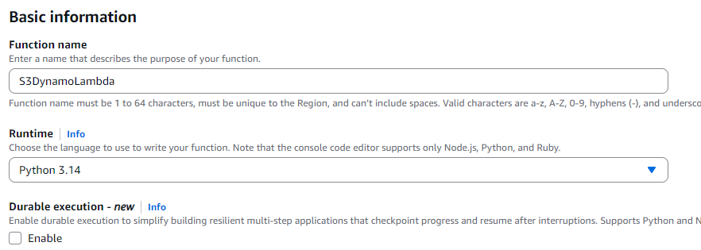

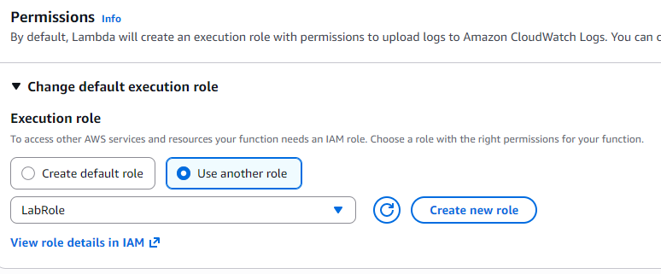
Click Create function.

5️ Add the Python Code
In Lambda → Code section, paste your code:
import boto3
from uuid import uuid4
def lambda_handler(event, context):
s3 = boto3.client("s3")
dynamodb = boto3.resource('dynamodb')
for record in event['Records']:
bucket_name = record['s3']['bucket']['name']
object_key = record['s3']['object']['key']
size = record['s3']['object'].get('size', -1)
event_name = record['eventName']
event_time = record['eventTime']
dynamoTable = dynamodb.Table('newtable')
dynamoTable.put_item(
Item={
'unique': str(uuid4()),
'Bucket': bucket_name,
'Object': object_key,
'Size': size,
'Event': event_name,
'EventTime': event_time
}
)
Click Deploy.

6️ Add S3 Trigger to Lambda

Or Adding trigger to connect the S3 bucket and DynamoDB
- In Lambda function page.
- Click Add Trigger.
- Select S3. // Search for S3 bucket in the trigger configuration
- Choose your bucket:
s3-lambda-trigger-bucket
- Event type:
  - All object create events
  - - Acknowledge
- Check Enable trigger.
- Click Add.
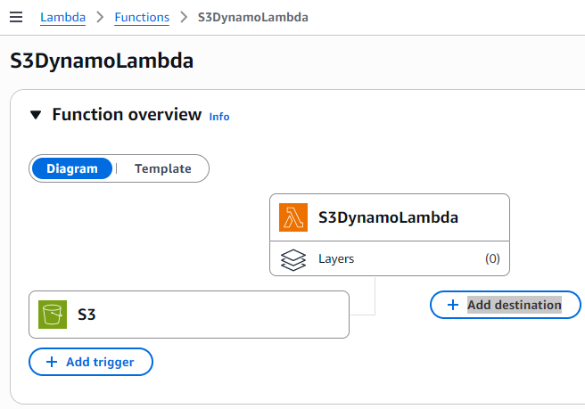

7️ Test the System
- Open S3 bucket.
- Upload any file (example: test.txt).
- The upload event will trigger the Lambda function.

8️ Verify DynamoDB Entry
- Open DynamoDB → Tables → newtable.
- Click Explore table items.
- You will see a record like:
unique | Bucket | Object | Size | Event | EventTime
UUID | bucket name | file name | size | ObjectCreated | time
✅ This confirms that S3 event triggered Lambda and updated DynamoDB.
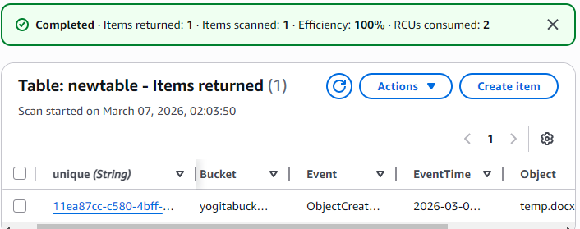
STEP-9 : Monitoring using cloud watch
-Click on the Monitor tab in the lambda function
-Click on the view cloudwatch logs
-Click on the time lines and check the logs

✔️ Architecture Flow
S3 Upload → Lambda Trigger → DynamoDB Record Stored
SBQ’s
1.A company wants to automatically process images whenever they are uploaded to an S3 bucket. The system should resize the images and store them in another bucket.
Which AWS service can be used to automatically run the code when the image is uploaded?
2.A developer created a Lambda function to store uploaded file details into a DynamoDB table, but the function fails with a permission denied error when writing to the database.
What could be the reason and how can it be fixed?
3.An application needs to run a piece of code every time a new file is uploaded to an S3 bucket to extract metadata and store it in a database.
How would you design this using AWS Lambda?
4.A Lambda function is configured with an S3 trigger, but it is not executing when files are uploaded.
What possible configuration issues might cause this problem?
5.A company wants to process only .jpg image files uploaded to an S3 bucket using Lambda.
How can the trigger be configured so that the function runs only for those files?
6.A Lambda function works correctly for a few uploads but fails when hundreds of files are uploaded simultaneously.
What AWS feature helps Lambda handle large numbers of events?
7.A developer wants to store the table name and bucket name separately from the code so that they can easily change them later.
Which Lambda feature can be used to achieve this?
8.A Lambda function executes but does not show any output in the console, making debugging difficult.
Which AWS service can be used to view logs and troubleshoot the issue?
9.An organization wants a function to run every day at 10 PM to clean temporary files stored in S3.
How can Lambda be triggered automatically at a scheduled time?

10.A Lambda function processes uploaded files and stores metadata in DynamoDB, but duplicate records appear in the table when the same file is uploaded again.
How can this issue be prevented?
11.A Lambda function processes files uploaded to S3, but the processing sometimes takes more than 10 minutes.
What limitation of Lambda must be considered here?
12.A developer wants to allow a Lambda function to read files from S3 and write records into DynamoDB.
What type of AWS security configuration must be created?
13.A company wants to automatically send a notification email whenever a file is uploaded to S3 using Lambda.
Which AWS services can be integrated to achieve this?
14.A Lambda function is triggered by S3 uploads, but the function keeps running multiple times for the same file.
What could be the possible cause?
15.An organization wants to build a fully serverless application where uploaded files are processed automatically without managing servers.
Which AWS services can be combined with Lambda to achieve this architecture?

